**KWAME NKRUMAH UNIVERSITY OF SCIENCE AND TECHNOLOGY**

**COLLEGE OF SCIENCE**

**DEPARTMENT OF COMPUTER SCIENCE**



**FINAL PROJECT DOCUMENTATION**

**PROJECT TOPIC**

**SMART IOT WASTE MANAGEMENT SYSTEM**

**PRESENTED BY:**

**NAME REFERENCE INDEX NUMBER**

**OSEI SAMUEL 20424351 6838716**

**KOBINA GUMYE FOLSON 20419032 6833516**

# DECLARATION

This project work entitled “IOT Smart Waste Management System” is submitted to the College of Science in partial fulfillment of the requirements for the award of the Degree of Bachelor of Science in Computer Science of Kwame Nkrumah University of Science and Technology.

# APPROVAL

This project proposal has been presented for examination with my approval as the supervisor.

Dr. Najim Ussiph.

SIGNATURE………………………………DATE………………………………

**TABLE OF CONTENT**

DECLARATION 2

APPROVAL 2

ABSTRACT 6

CHAPTER 1 – INTRODUCTION 7

1.0 - Background 7

1.1 - Problem Statement 9

1.2 - Aim Of The Project 9

1.3 - Specific Objectives 10

1.4 - Project Scope 10

1.5 - Project Justification 10

1.6 - Project motivation 10

1.8 - Project Beneficiaries 11

CHAPTER 2 - REVIEW OF RELATED WORKS 12

2.0 - Review Of Related Systems 12

2.1 - Overview Of System 1: Incineration 12

2.1.1 - Good Features 12

2.1.2 - Bad Features 13

2.2 - Overview Of System 2: Landfills 14

2.2.1 - Good Features 14

2.2.2 - Bad Features 15

2.3 - Overview Of System 3: Dumpsites 15

2.3.1 - Good Features 15

2.3.2 - Bad Features 15

CHAPTER 3 – REQUIREMENT SPECIFICATION 16

3.1 – Overview 16

3.2 –Functional and Non-Functional Requirements 16

3.2.1 – Non – Functional Requirement. 16

3.2.1 – Functional Requirement. 16

3.3 – User and System Requirements 17

3.3.1 – User Requirement. 17

3.3.2 – System Requirement. 17

3.4 – UML Diagram 18

3.4.1 – Class Diagram. 18

3.4.2 – Use Case Diagram 19

CHAPTER 4 - METHODOLOGY 20

4.0 - Overview 20

4.1 - Project Method Adopted And Justification 20

4.1.1 – Incremental model 20

4.2 – Project Design 21

4.2.1 – Customer Interface Application. 22

4.3.1 – Driver Interface Application. 29

4.4.1 –Administrator Interface Application. 33

4.5.1 – Smart IoT Based Architecture. 37

4.5.1.1 – Hardware Setup 37

4.5.1.2 – Components Design 38

Ultrasonic Sensor 38

Arduino Uno Board 38

4.6.1 – Database Design 39

CHAPTER 5 - IMPLEMENTATION AND TESTING 40

5.0 - Development Tools And Platforms Consideration 40

5.1 Mapping Logical Design Onto Physical Platforms 40

5.4 - Testing 41

5.4.1 - Units/Components Testing 42

5.4.2 - Integration And System Testing 43

5.4.3 - Deployment Model And Platforms 44

5.4.4 - Acceptance Testing 45

CHAPTER 6 - CONCLUSIONS AND RECOMMENDATIONS 46

6.0 - Discussions 46

6.1 - Achievements 46

6.2 - Conclusions 46

6.4 - Recommendations 46

6.5 - References 47

**TABLE OF FIGURES.**

Figure 0‑1 Class Diagram. 18

Figure 0‑2 Use Case Diagram 19

Figure 0‑1 incremental model 21

Figure 0‑2 Sign Up page 22

Figure 0‑3 Login Page. 23

Figure 0‑4 Customers’ Home Page 24

Figure 0‑5 Customer Profile. 25

Figure 0‑6 Paypal Subscription Checkout. 26

Figure 0‑7 All the navigation menus 28

Figure 0‑8 Drivers login Page. 29

Figure 0‑9 Drivers’ homepage 30

Figure 0‑10 Dustbins assigned to driver 31

Figure 0‑11 Smart Dustbin notification to a driver 32

Figure 0‑12 Admin home page. 33

Figure 0‑13 Admin Profile Page 34

Figure 0‑14 Admin Popup to Update Details 34

Figure 0‑15 Customers Profile 35

Figure 0‑16 Dustbin Maps. 36

Figure 0‑17 Messages page. 36

Figure 0‑18 Trash Talker circuit 37

Figure 0‑19 Ultrasonic Sensor 38

Figure 0‑20 Arduino Uno Board 38

Figure 0‑21 Database Design 39

# ABSTRACT

The purpose of this research is implementing an IOT smart Waste Management System which is based on web app and IOT hardware which optimize waste collecting schedules by tracking waste levels, as well as providing route optimization and operational analysis and allowing institutions and companies to sign up to the services the system provides. The software model used in used in developing this system is incremental model of System Development Life Cycle (SDLC). It has the following phases: analysis design, implementation, testing, maintenance in which each iteration passes through the requirements, design, coding and testing phases and determining the features needed in developing application and making the detail definition of each features, system and software design, user interface design, Unified Modeling Language(UML) design, and database structure design. This system will be developed using PHP, Python, HTML, CSS, JavaScript as the programming language for developing the clients’ side and the server side and Structured Query Language (SQL) for developing the database for the system, which is open source and has cross platform operability.

# CHAPTER 1 – INTRODUCTION

## 1.0 - Background

Waste management is one of the major challenges facing the world, especially in this modern time where we generate more and more waste each day. Different methods have been used to try and curb this problem such as the use of technology but this has still not been able to effectively manage the waste generated in communities. Waste management as a social problem has neither spared the developed or developing nations as statistics have shown that some developed nations are seriously grappling with this bane (Chazan, 2002). According to Lyse, 9 out of every 10 African cities are facing serious waste disposal problems (Lyse, 2003: 1). Indeed, a visit to some cities and towns in Ghana revealed aspects of the waste management problem such as heaps of uncontrolled waste, polythene bags scattered everywhere and disposal sites overflowing with filth which comes with its associated health hazards such as cholera, malaria, and typhoid to residents who live near the dumping sites.

Before deciding to work on this project, much research was done into scientific areas concerned with the topic. Information was gathered from various literary sources such as textbooks, internet websites, environmental news reports, reports by governmental agencies, and environmental progress reports from different agencies, international scientific journals, an amount of meaningful knowledge was gathered and also a review of other scientific works was done. After all this, another literature review was done to acquire a level of understanding concerning the field of impact of urban waste on the quality of groundwater and soil and the individual in different areas.

There are many organizations that are doing what they can to solve this issue we face when it comes to waste management. Internationally organizations like World Health Organization (WHO), Environmental Protection Agency (EPA), and United Nations Environment Program (UNEP) are engaged in developing new technologies for waste management and its disposal including its characterization.

In Ghana there are quite a number of waste management institutions, to name a few rapid waste limited, Zesta Environmental Solutions Limited, Sewage Systems Ghana limited and one of the most notable institutions are the company Zoomlion. They have done the best they can to keep our cities clean but they can only do so much.

Most waste collection operators empty containers according to predefined schedules. This is not a very efficient approach since it leads to the unproductive use of waste containers and unnecessary fuel consumption by waste collecting trucks.

IoT-enabled smart city solutions help to optimize waste-collecting schedules by tracking waste levels, as well as providing route optimization and operational analytics.

Each waste container gets a sensor that gathers the data about the level of the waste in any container that measures the level in centimeters. Once it is close to a certain threshold, the waste management solution receives a sensor record, processes it, and sends a notification to a truck driver’s app. Thus, the truck driver locates the bin with the help of google map coordinates which sends the exact location of the bin to the driver. The driver then reaches the bin and empties the container, avoiding emptying half-full ones and overfull containers.

TYPES OF WASTE

SOLID WASTE

Solid waste can include a variety of items found in your household along with commercial and industrial locations.

Solid waste is commonly broken down into the following types:

* Plastic waste – This consists of bags, containers, jars, bottles, and many other products that can be found in your household. Plastic is not biodegradable, but many types of plastic can be recycled. Plastic should not be mixed in with your regular waste, it should be sorted and placed in your recycling bin.
* Paper/card waste – This includes packaging materials, newspapers, cardboards, and other products. Paper can easily be recycled and reused so make sure to place them in your recycling bin or take them to your closest Brisbane recycling depot.
* Tins and metals – This can be found in various forms throughout your home. Most metals can be recycled. Consider taking these items to a scrap yard or your closest Brisbane recycling depot to dispose of this waste type properly.
* Ceramics and glass – These items can easily be recycled. Look for special glass recycling bins and bottle banks to dispose of them correctly.

HAZARDOUS WASTE

Hazardous waste refers to all types of waste that are flammable, toxic, corrosive, and reactive.

Hazardous waste is generated from a wide range of industrial, commercial, agricultural, and to a much less extent, domestic activities. They may take the form of solids, liquids or sledges, and can pose both acute and chronic public health and environmental risk.

## 1.1 - Problem Statement

There are many issues we are face in this country one of which has to do with waste management and a tidy environment. As you walk or drive around the streets of the country, it is clear that sanitation is a very big problem that we face as you will always find some refuse littered along the streets and in corners. This gives rise to many other issues such as air pollution, the air becomes unpleasant to breathe because of the odor emanating from the refuse which piles up in the community due to the fact that an unclean environment gives rise to disease outbreaks which not handled properly can result in many complications and ultimately death.

There are many areas where waste is collected into large containers, but they are not regularly emptied. As a result, the waste overflows from these containers and therefore making their surroundings unsightly.

## 1.2 - Aim Of The Project

We would like to be part of the solution to helping the nation take its first steps to proper waste disposal and management. So as students we have taken it upon ourselves to develop a system to help us curb this issue and to accomplish this, we came up with the trash management system to ensure prompt collection of garbage from bins and containers that have been filled up with waste.

## 1.3 - Specific Objectives

To ensure timely collection of refuse from local communities

To prevent pilling of waste at collection areas

To ensure proper use of resources

To create a web page that allows users to subscribe to the services we provide

## 1.4 - Project Scope

So basically the idea behind this project is to design a system that will be able to detect garbage level and then notify the appropriate officials of the current status of the different garbage bins in the city. A web application is designed to allow users such as hospitals, industries, schools, homes and communities to subscribe to our services to make their environment clean by giving them smart dustbins that detect and send notifications to system officials when it reach threshold. A real-time monitoring is also provided along with a remote-controlled IoT technique.

## 1.5 - Project Justification

As responsible members of society, we have to ensure that our environment is clean. Taking into consideration the system used in major cities such as Accra, waste is collected from their containers according to schedules and routes which have already been determined beforehand. On serious analysis of this system, we have realized their many disadvantages with this system of doing things such as:

Time-consuming, high costs, Unnecessary fuel consumption, air pollution

## 1.6 - Project motivation

As students when the time came for us to work on our project we decided to look at our community and country as a whole and tried to identify the various problems which we are facing. We realized sanitation is one of the things which is overlooked in this country even though it is very important especially when it comes to health. Our planet is suffering from our improper practices when it comes to waste disposal and management. To be more specific we are referring to ozone depletion and our country Ghana is not making much effort to be part of the solution.

## 1.8 - Project Beneficiaries

This project aims to reduce the amount of waste left unattended in major areas of the community where waste is gathered to be dispose off. In doing this, the members of the community will be the main beneficiaries of this system as it helps to keep their surroundings tidy and clean and in doing so also prevent any unwanted health issues which arise from living in close proximity to waste. The waste companies who take care of this waste will also benefit as the system makes their work much more efficient as they do not have to waste resources frequently checking the various areas for waste containers that are full. And they will gain income as companies will subscribe to the services.

# CHAPTER 2 - REVIEW OF RELATED WORKS

## 2.0 - Review Of Related Systems

## 2.1 - Overview Of System 1: Incineration

Municipal solid waste (MSW) incineration plants tend to be among the most expensive solid waste management options, and they require highly skilled personnel and careful maintenance. For these reasons, incineration tends to be a good choice only when other, simpler, and less expensive choices are not available. Because MSW plants are capital-intensive and require high maintenance costs and comparatively higher technically trained operators, they are commonly adopted by developed countries. However, high capital and maintenance costs may make MSW incineration beyond the reach of many of the lesser developing countries. The Decision Makers’ Guide aims to reduce such mistakes by clarifying some of the basic requirements for a successful incineration plant project.

There are various ways by which waste is handled in different parts of the country one popular method of disposing of the waste is by incineration.

This method is carried out by some individuals or households who gather their waste and go out to find some open area or bush where they dump the waste and then set it on fire.

### 2.1.1 - Good Features

1. Decreases quantity of waste. Burning decreases the quantity of waste by 95% and reduces the solid quantity of the original waste by 80-85% depending on the components that were in [solid waste.](https://www.conserve-energy-future.com/sources-effects-methods-of-solid-waste-management.php) Hence, even though burning does not completely get rid of dumping ground, they definitely decrease the quantity of land needed.
2. Reduction of Pollution. Compared to other methods of waste disposal burning has less effect on the environment in terms of pollution.
3. Saves on Transportation of Waste. It significantly reduces the cost of transport; the money can then be spent on the wellbeing of the community and sustaining the growth of a city or the district. Additionally, it reduces the harmful gases released by vehicles during transportation, thus drastically reducing the overall carbon footprint.

### 2.1.2 - Bad Features

Backyard burning produces various compounds toxic to the environment including nitrogen oxides, volatile organic compounds (VOCs), carbon monoxide, and particle pollution.

* Nitrogen oxides, or NOx, is a group of nitrogen compounds that are partially responsible for acid rain and contribute to global warming, ozone depletion, and the formation of smog.
* Volatile organic compounds, or VOCs, are carbon-based compounds that undergo photochemical reactions (i.e., they react with sunlight) when released into the atmosphere. The VOCs and the compounds they form in the atmosphere, such as ozone, contribute to the formation of smog.
* Carbon monoxide, or CO, chemically reacts with sunlight to create harmful ozone. CO production can significantly impact ambient air quality and a region's ability to meet Clean Air Act regulatory air quality standards. Burning garbage in a barrel or pile produces more CO than decomposition in a landfill. CO is also a significant greenhouse gas.
* Particle pollution, also known as particulate matter, or PM, refers to the fine particles that produce visible smoke that reduce visibility and creates haze, which is a major air pollution problem for many rural communities. In addition to being unhealthful, particles soil our homes and cars and transport dangerous chemicals, such as dioxins.

## 2.2 - Overview Of System 2: Landfills

There are two ways to bury trash:

**Dump** - an open hole in the ground where trash is buried and that has various animals (rats, mice, birds) swarming around. (This is most people's idea of a landfill!)

**Landfill** - carefully designed structure built into or on top of the ground in which trash is isolated from the surrounding environment (groundwater, air, rain). This isolation is accomplished with a bottom liner and daily covering of soil. A **sanitary landfill** uses a clay liner to isolate the trash from the environment. A **municipal solid waste (MSW) landfill** uses a synthetic (plastic) liner to isolate the trash from the environment.

The purpose of a landfill is to bury the trash in such a way that it will be isolated from groundwater, will be kept dry, and will not be in contact with air. Under these conditions, trash will not decompose much. A landfill is not like a **compost** pile, where the purpose is to bury trash in such a way that it will decompose quickly.

### 2.2.1 - Good Features

**1. Landfills are convenient to use.**

They don’t need the waste to be transported from its source where it is generated to another distant or remote area where it would be dumped. The cost of transporting the humongous waste, especially from large cities to remote regions of the country can run into millions in a year. The fact that the peripheral areas of most metropolises and even suburbs have become developed and cannot have landfills further complicates the challenge.

**2. Landfills can use the waste generated in a city, town, or district and produce energy.**

There can be confined landfills that are not exactly next to human habitation or farmland and can be safely used in an eco-friendly way to generate energy that can power the needs of the facility and the locals. The carbon dioxide and methane exuding from landfills can be harnessed to generate power. This also reduces the quantum of the waste present in landfills.

### 2.2.2 - Bad Features

1. Production of harmful gases. In landfills, when the waste is decaying methane gas is generated which if not controlled, may explode [causing further global warming](https://www.conserve-energy-future.com/various-global-warming-facts.php).
2. Pollution of underground water sources. Landfills also leach poisonous chemicals into the water below thus contaminating underground water systems.

## 2.3 - Overview Of System 3: Dumpsites

With this method, individuals dump waste at specific sites whenever they need to dispose of any waste they have gathered

### 2.3.1 - Good Features

1. It is inexpensive and convenient.
2. It is easy to use.
3. It is user friendly.

### 2.3.2 - Bad Features

1. Health-hazard - insects, rodents etc.
2. Damage due to air pollution
3. Groundwater and run-off pollution

# CHAPTER 3 – REQUIREMENT SPECIFICATION

## 3.1 – Overview

This system is an IoT based system that takes a reading of the status of garbage bins and notifies the proper authorities to empty them. This service is to be available to communities and organizations or companies. In order to reach these groups, a web application is also provided to allow one to register for the service, which could be a company, hospital or an institution.

## 3.2 –Functional and Non-Functional Requirements

### 3.2.1 – Non – Functional Requirement.

Non – functional requirements are complementary features that support the work of the system which have indirect effect. Some of the non-functional requirements in building this system are:

* **Performance:** A fast and stable internet connection is required for the system to run perfectly and smoothly.
* **Security:** With the help of PHP and SQL encryption, the database and customers details are encrypted in the database to prevent hackers from gaining access to customers’ information.
* **Usability:** The system provide user-friendly environment which attracts users to stay on the page.
* **Reliability:** The system is reliable enough to locate every user on the map with the aid of the digital addressing system.

### 3.2.1 – Functional Requirement.

The proposed system is required to perform some important functions. These include:

**Customers Registration** – The system allows groups such as companies, hospitals and any institution to subscribe for a paid service.

**Detection of Waste levels** – The system should be able to detect level of wastes in the bin.

**Sending of detailed messages –** After reaching threshold, which is the brim of the bin, the system then sends notification to appropriate official which is the admin and the assigned driver to handle the waste disposal.

**Locations of bins –** With the help of google maps integration, the system shows the exact location of the bin which is full for easy location for the driver in charge.

## 3.3 – User and System Requirements

### 3.3.1 – User Requirement.

User requirements are user needs that the user does with the system, the activities the user perform with the system. Some are:

* Users can visit the site.
* Allow users to explore the whole web page.
* Allows users to sign up.
* Allows users to subscribe to services.
* Allows users to send messages to the admin.

### 3.3.2 – System Requirement.

These are hardware and software components of a computer that are required to be able to install and use the software efficiently.

**The software components are:**

* Windows Operating System
* MAC Operating System
* Android Operating system

**The hardware components are:**

* Processor speed of 1GHZ or more
* RAM of 1GB or above
* Storage speed of 80MB or more

## – UML Diagram

### 3.4.1 – Class Diagram.

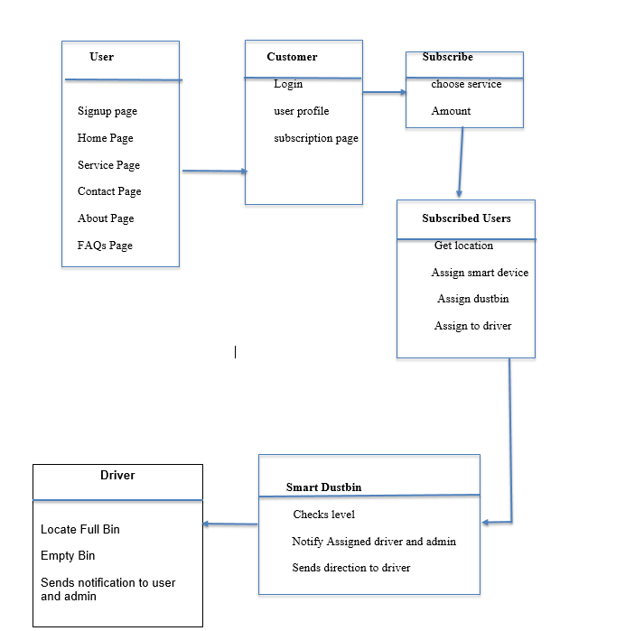

Figure ‑ Class Diagram.

### 3.4.2 – Use Case Diagram

The user interactions with the system are as follows;

* Customer entity: register, login, subscribe.
* Administrator: update and react to customers and drivers’ messages.
* Driver; locate and empty full dustbins.

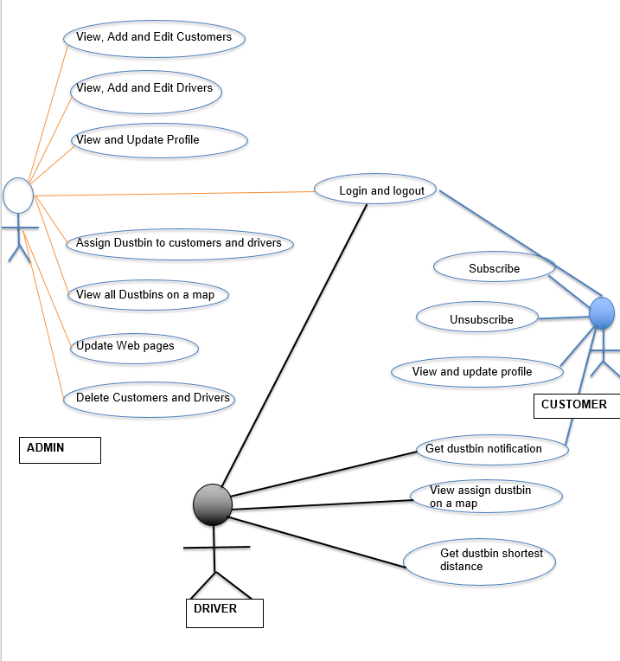

Figure ‑ Use Case Diagram

# CHAPTER 4 - METHODOLOGY

## 4.0 - Overview

This system is an IoT based system that takes a reading of the status of garbage bins and notifies the proper authorities to empty them. This service is to be available to communities and organizations or companies. In order to reach these groups, a web application is also provided to allow one to register for the service.

## 4.1 - Project Method Adopted And Justification

To develop this project after much research we concluded that the best approach would be to use a flexible and Incremental model.

### 4.1.1 – Incremental model

Incremental model is a software development process where requirements are broken down into multiple standalone modules of software development cycle. Incremental development is done in steps form analysis design, implementation, testing/verification and maintenance. Each iteration passes through the requirements, design, coding and testing phases. And each subsequent release of the system adds function to the previous release until all designed functionality has been implemented. The system is put into production when the first increment is delivered. The first increment is often a core product where the basic requirements are addressed, and the supplementary features are added in the next increment.

Characteristics of the incremental software design model include.

* System development is broken down into many mini development projects
* Highest priority requirement is tackle first.
* Partial systems are successively built to produce a final total system.
* Once the requirement is developed, the requirement for that increment are frozen

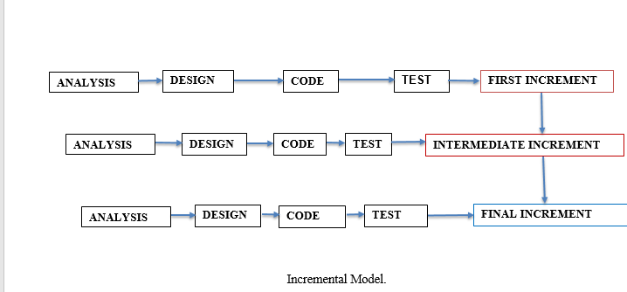

Figure ‑ incremental model

Advantages of the adopted model

* Throughout the development process, changes can be make.
* It is flexible

For the IoT set up the incremental model was used as it was the most suitable method for obtaining the best results. This is because the incremental model may be an agile process that interleaves the activities of specification, development, and validation which we made sure to follow to the best of our abilities. Taking a deeper look into these activities you will be able to get a better understanding of our model choice.

## 4.2 – Project Design

This system is an IoT physical system that performs a pre-programmed function. Therefore there is no user interface to interact with hardware, only the developer of the system can interact with the hardware using programmable codes.

However, we have also developed a web application where those interested in the system can register on the site and select the package they desire and subscribe to a paid service and also to manage their profiles. Here are some screenshots of the application.

### 4.2.1 – Customer Interface Application.

Fig. 1.1 – **Sign Up page**

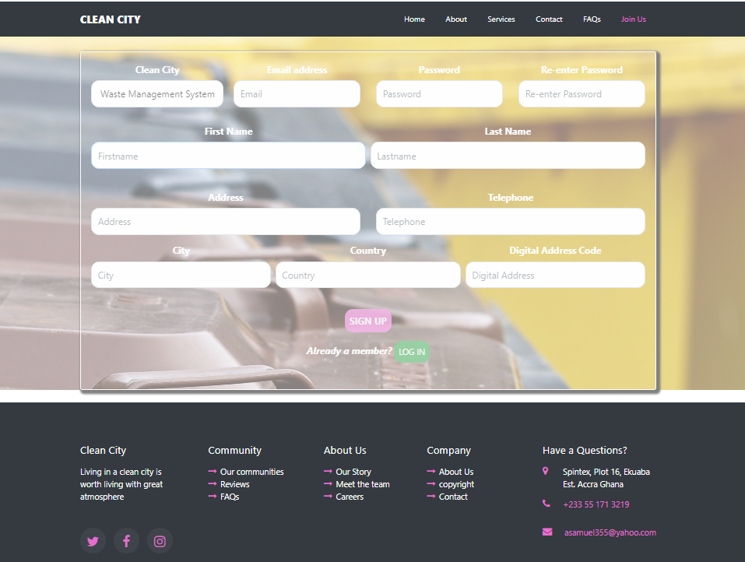

Figure ‑ Sign Up page

The above figure shows the sign-up page that gets users personal details to be stored into a database. After registration, an activation link is send to the user’s email for confirmation before the user gets fully registered to become a customer.

Fig. 1.2 – **Login Page.**

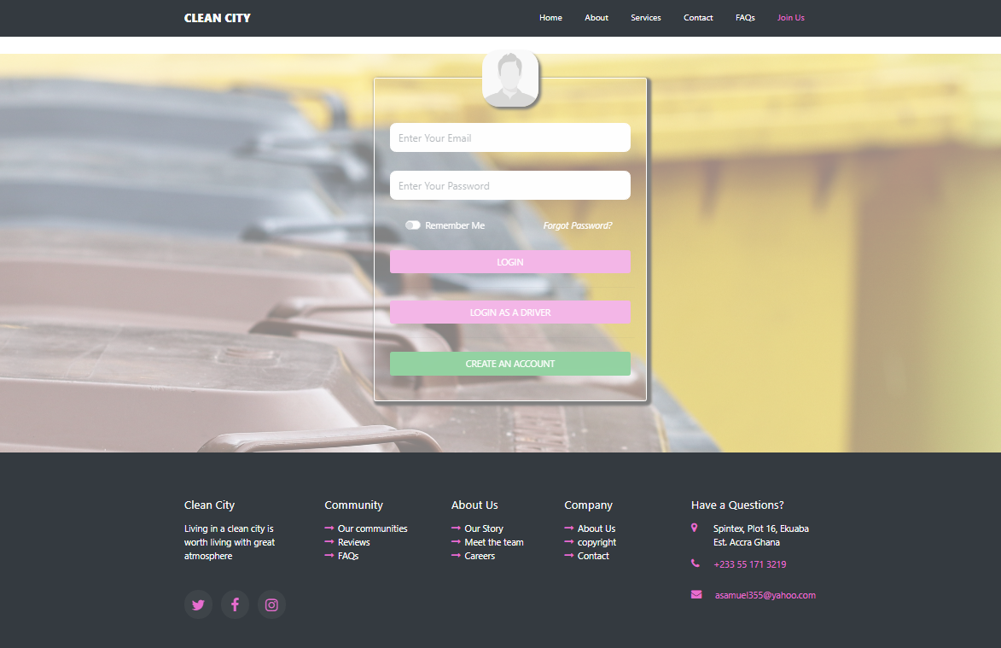

Figure ‑ Login Page.

The figure above shows a login page that allows customers to get into their accounts. Customers who have lost or forgotten their password can reset their password after following instructions for password resetting. Correct credentials entered by the customers get them into their various accounts

Fig. 1.3 – **Customers’ Home Page**

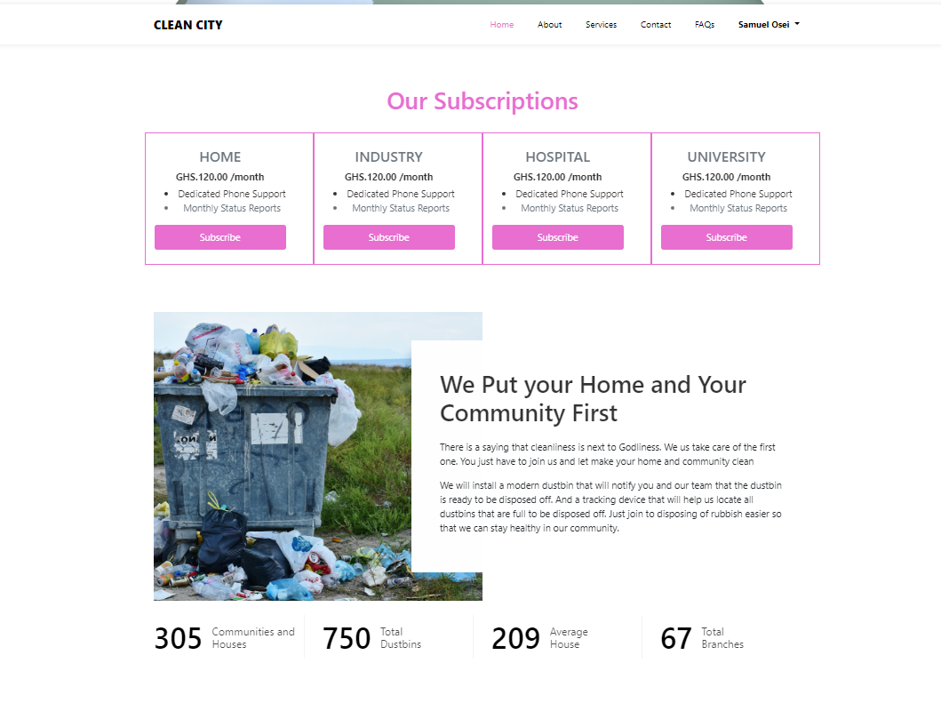

Figure ‑ Customers’ Home Page

The figure 1.3 shows the homepage of the system and the session of every customer. It displays various kinds of subscriptions every customer can choose from. The subscriptions are; Home, Industry, Hospital and University. Every customer can subscribe to any of the services that suit their needs.

Fig. 1.4 – **Customer Profile.**

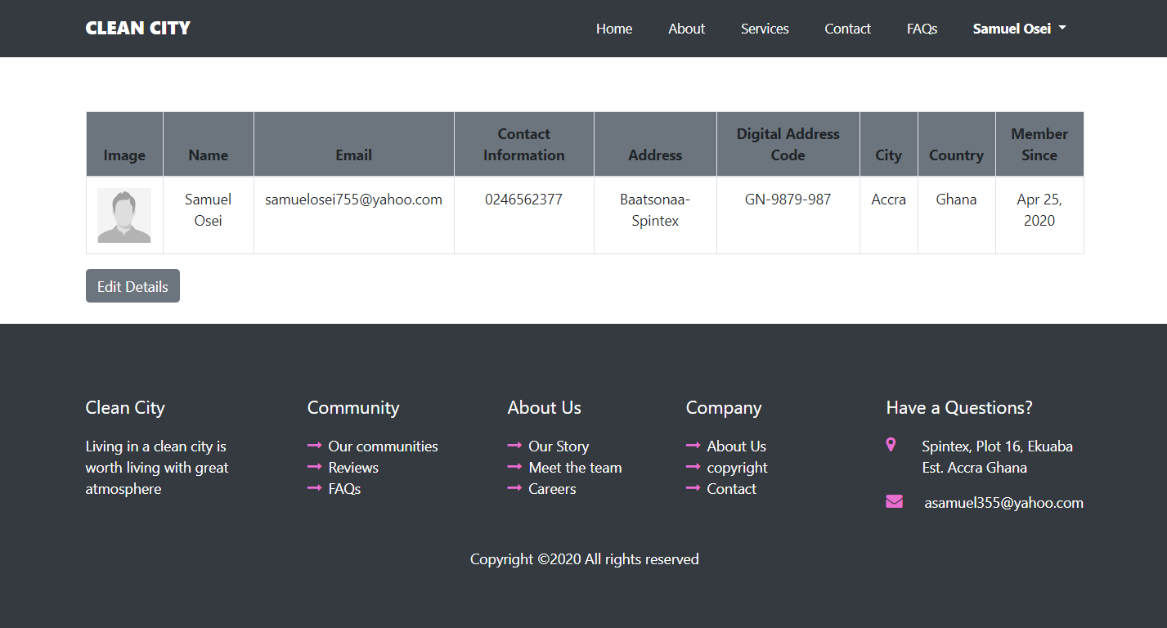

Figure ‑ Customer Profile.

Figure 1.4. Displays the profile of the customer where he or she can view, edit and update his or her details. By clicking on “**Edit Details**”, the customer can update his or her profile details.

Fig. 1.5 – **Subscription Checkout.**

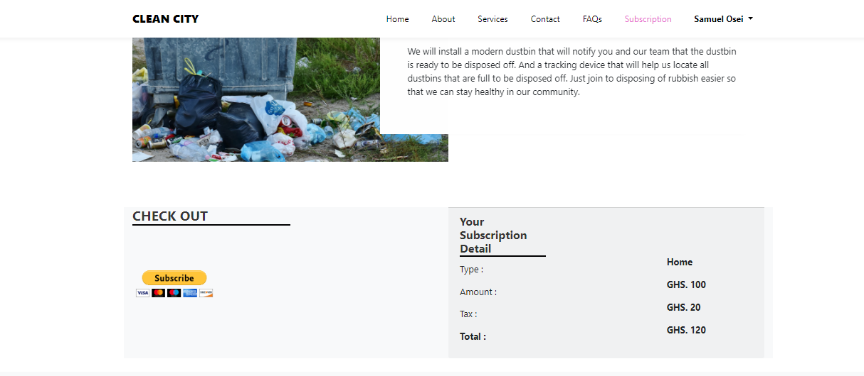

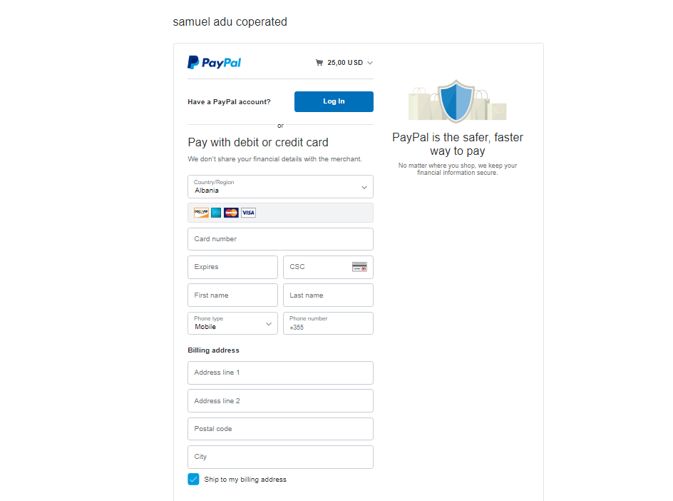

Figure ‑ Paypal Subscription Checkout.

The pages above allow customers to subscribe to the available services (Home Subscription, Industry Subscription, Hospitals Subscription and Institutions Subscriptions). They subscribe through a secure payment system, which is PayPal. It is one of the best payment system which is safer and easier way to make payments online. Customers can subscribe and unsubscribe to the available services. After successful subscription, the administrator gets notified with the payments and sets dustbins to the subscribed customer.

Fig. 1.6 All the navigation menus

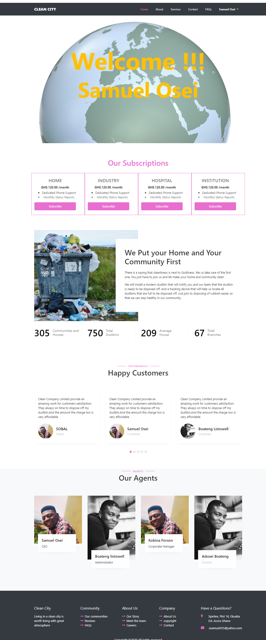

Figure ‑ All the navigation menus

**Fig. 1.6.** Shows all the navigation menus a customer can access on the webpage. A Customer can do the following:

* Views all the pages by navigating through the menus.
* Views all the subscription services and subscribe to one which is suitable.
* Declines subscriptions after subscribing
* View, Edit and update personal information
* Change password
* Sign out.

### 4.3.1 – Driver Interface Application.

**Fig. 2.1 Drivers login Page.**

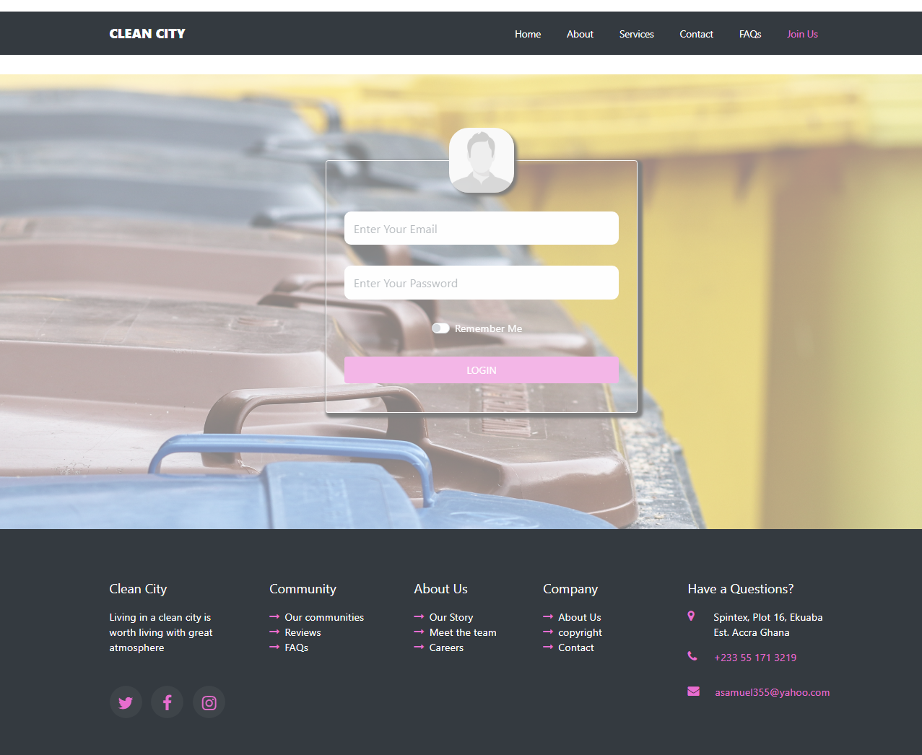

Figure ‑ Drivers login Page.

Fig. 2.1.Shows a login page that allows drivers to get into their accounts. Correct credentials entered by the driver get him/her into their various accounts.

**Fig. 2.2. Drivers’ homepage**

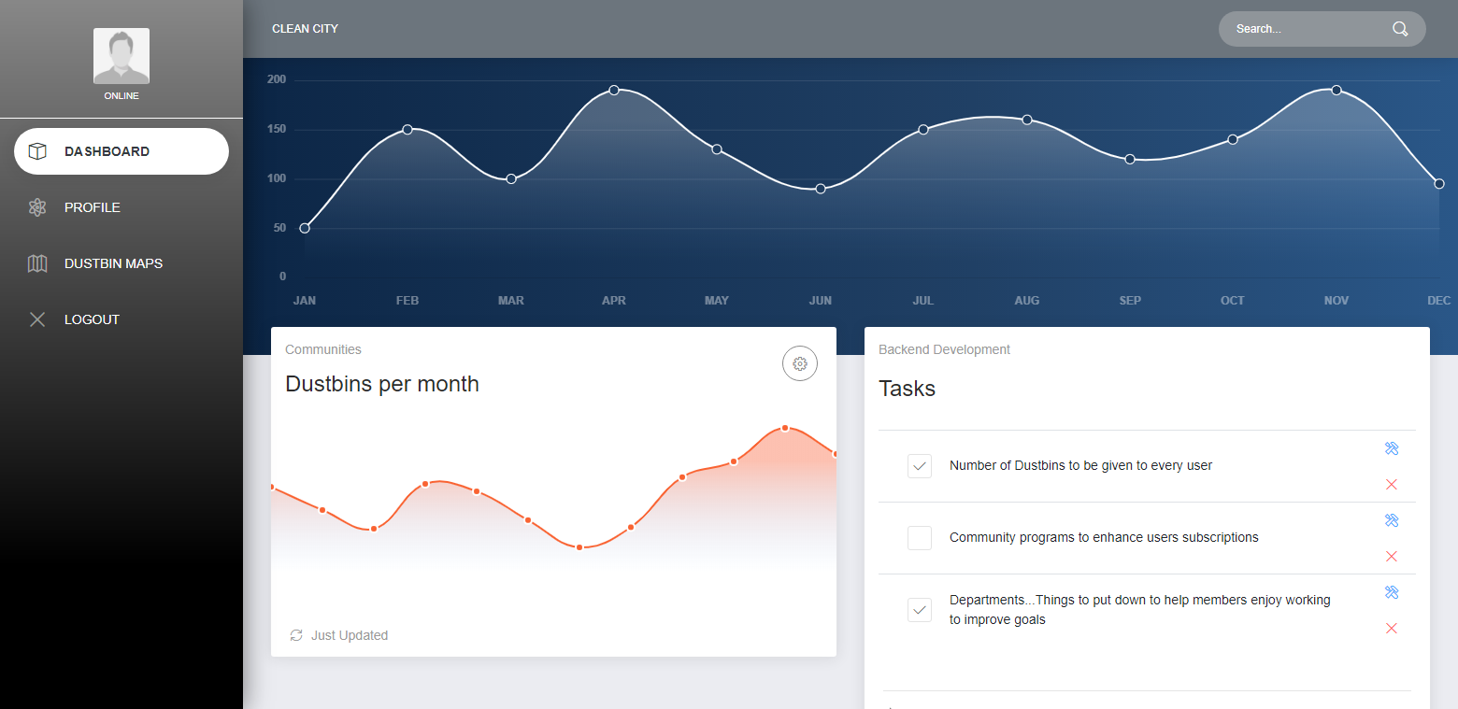

Figure ‑ Drivers’ homepage

Fig. 2.2 shows the home page of each drivers’ session that displays dustbins distributed per month and upcoming tasks which have been scheduled for a particular driver.

**Fig. 2.3 Dustbins assigned to driver**

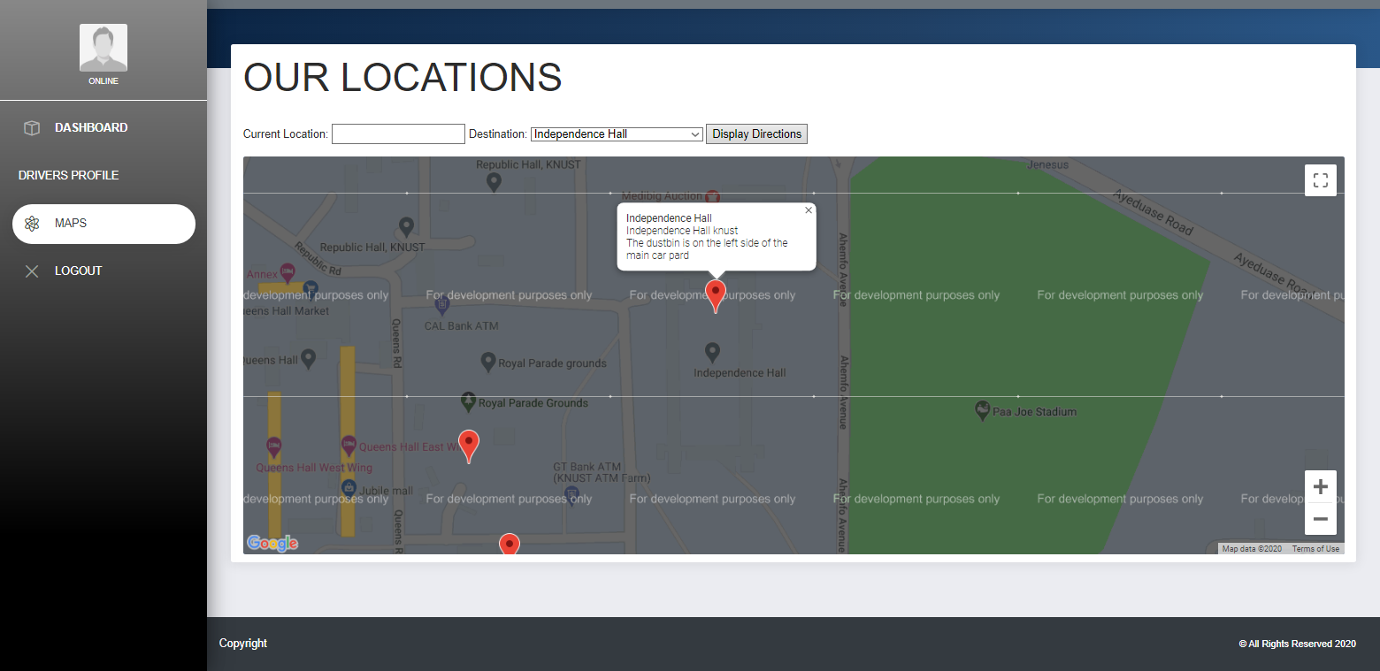

Figure ‑ Dustbins assigned to driver

Fig. 2.3 Displays all the dustbins which have being assigned to a particular driver on a map. If each dustbin is full, the system sends notification (location) to the driver through email for easy identification.

**Fig. 2. 4.** Smart Dustbin notification to a driver

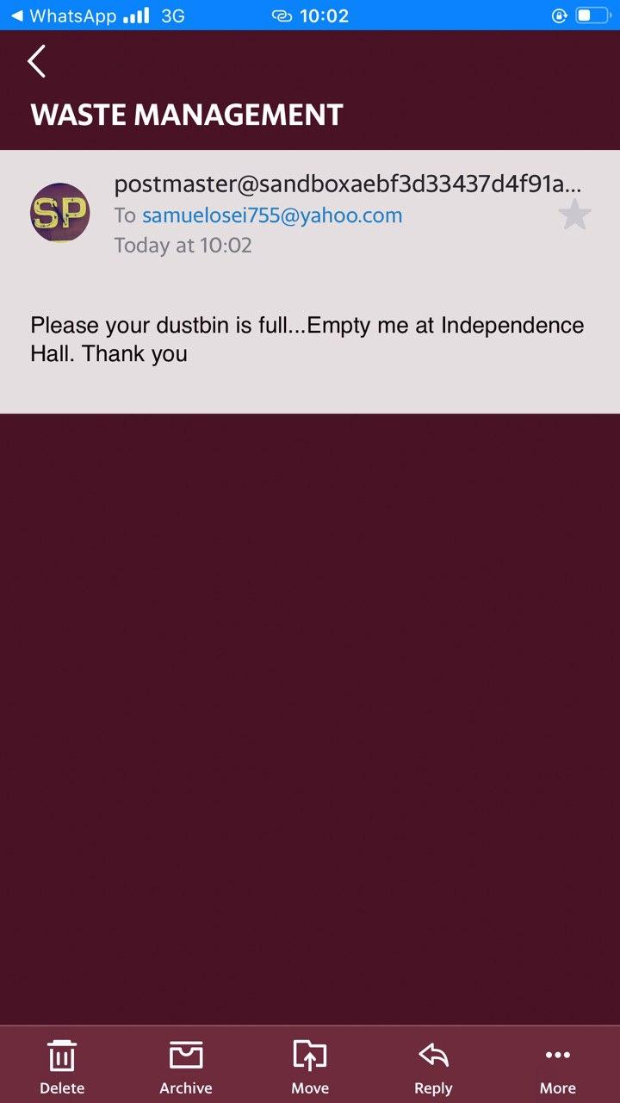

Figure ‑ Smart Dustbin notification to a driver

The figure above is mailed notification from a smart IOT based dustbin. It send the notification to the assigned driver which is full and it is ready to be emptied.

### 4.4.1 –Administrator Interface Application.

**Fig. 3.1. Admin home page.**

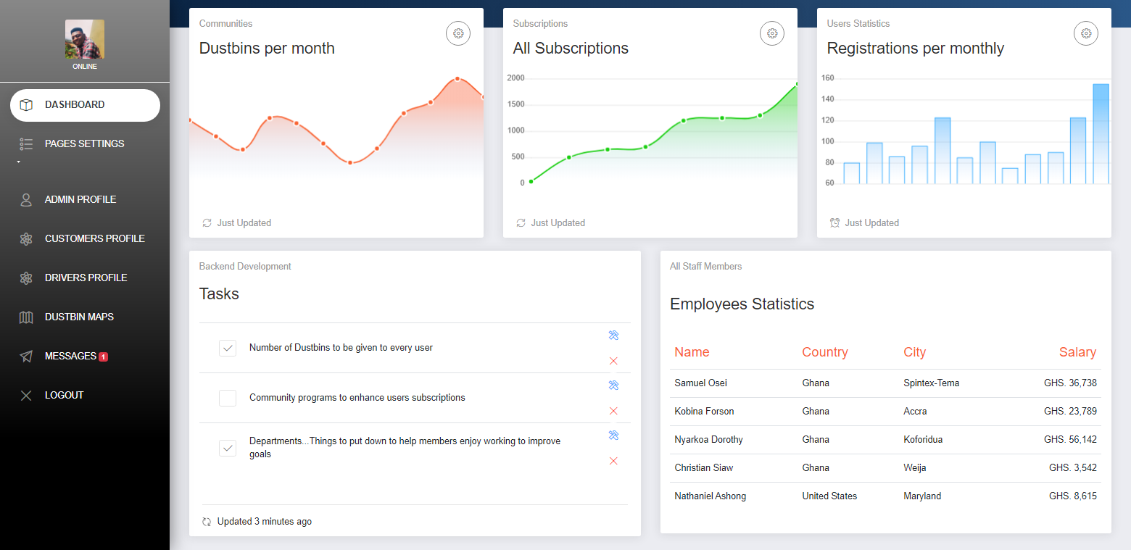

Figure ‑ Admin home page.

Fig. 4.1 displays the admin home page. It displays subscriptions, Registrations Statics and tasks.

The left panel displays menu options for the admin to perform actions. An admin can:

* + - 1. Update the various pages of the site.
      2. View and update his profile
      3. View, edit, update and delete customers.
      4. View, edit, update and delete drivers.
      5. Respond to messages send to the server.
      6. Create account for both customers and drivers
      7. Activate and deactivate customers’ accounts.
      8. Assign dustbins to customers.
      9. Assign dustbins to drivers.
      10. View all the dustbins on a map.
      11. Sign out.

Fig. 3.2 **Admin Profile Page**

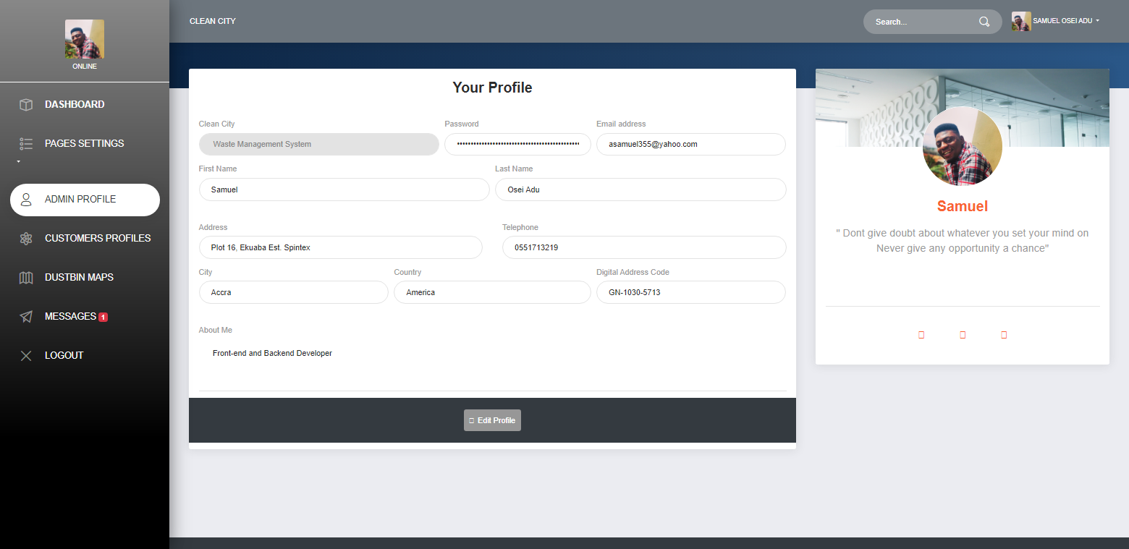

Figure 0‑13 Admin Profile Page

Fig.3.3 Admin Popup to Update Details

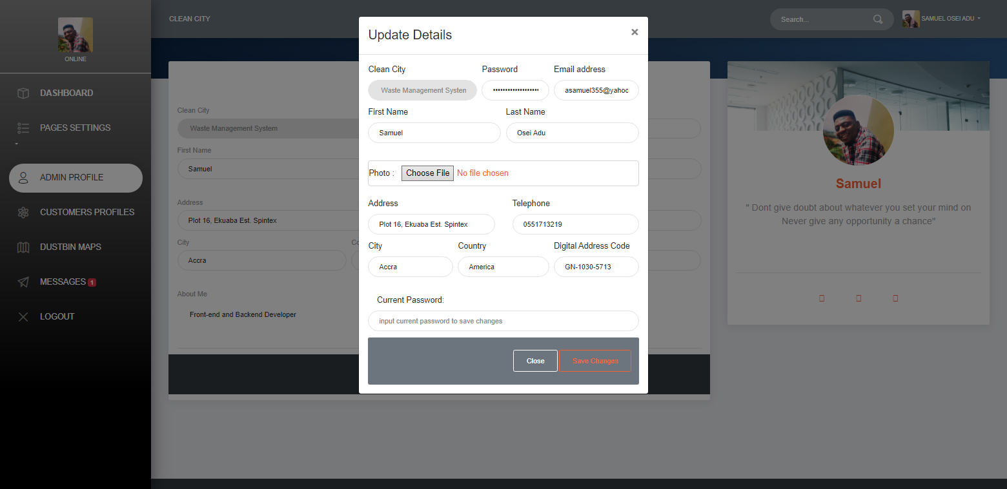

Figure ‑ Fig.4.3 Admin Popup to Update Details

Figure 3.2 above displays the admin profile page, where he can edit and update his personal details.

Fig 3.3 shows a pop up window that allows the admin to make changes to his profile.

Fig. 3.4 Customers Profile

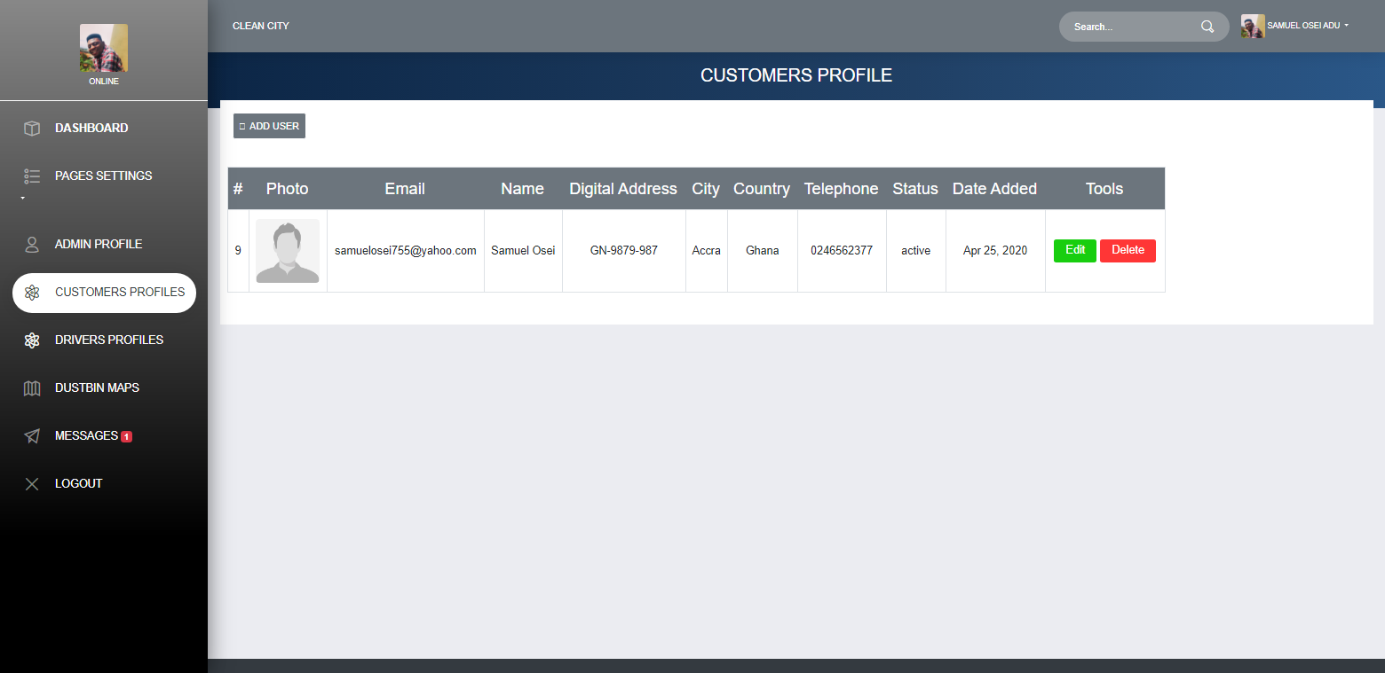

Figure ‑ Customers Profile

Fig. 3.4. Displays all the customers’ details who have signed up.

Admin can add by clicking the ‘add user’ button to add new customer.

Admin can edit and update customers’ profile. Admin can also delete customers’ accounts.

Fig. 3.5. Dustbin Maps.

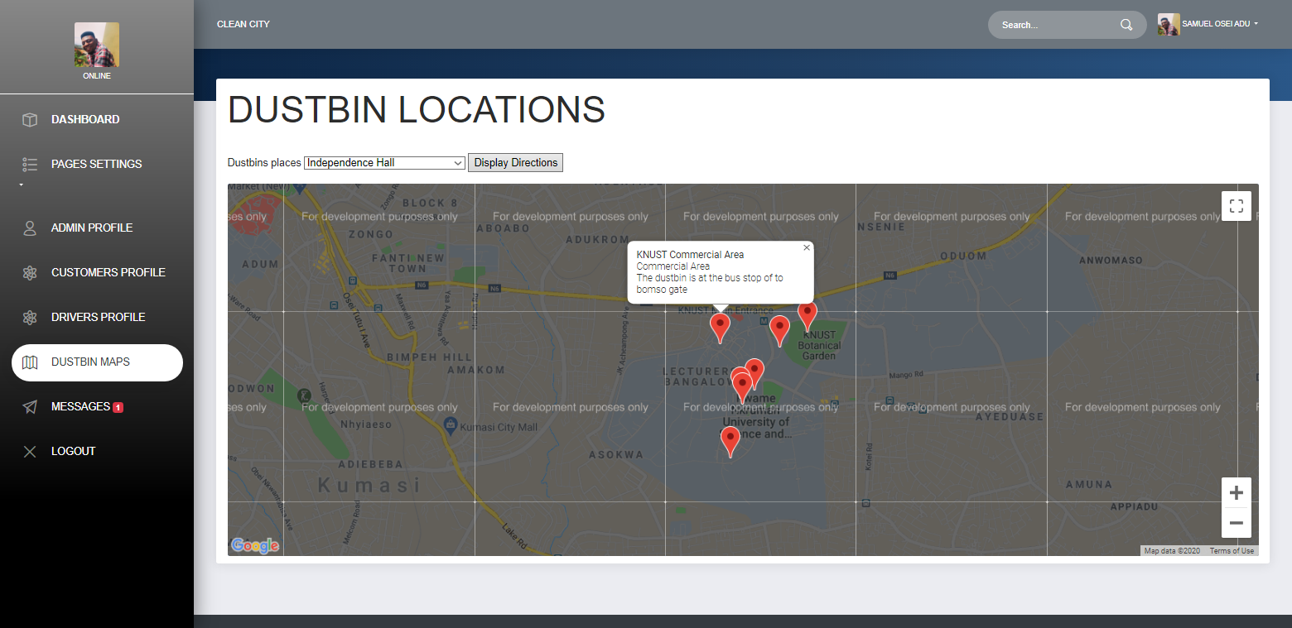

Figure ‑ Dustbin Maps.

Fig. 3.5. Displays all the dustbins which have been placed on the map for easy identification for the drivers when they get full.

**Fig. 3.6 Messages page.**

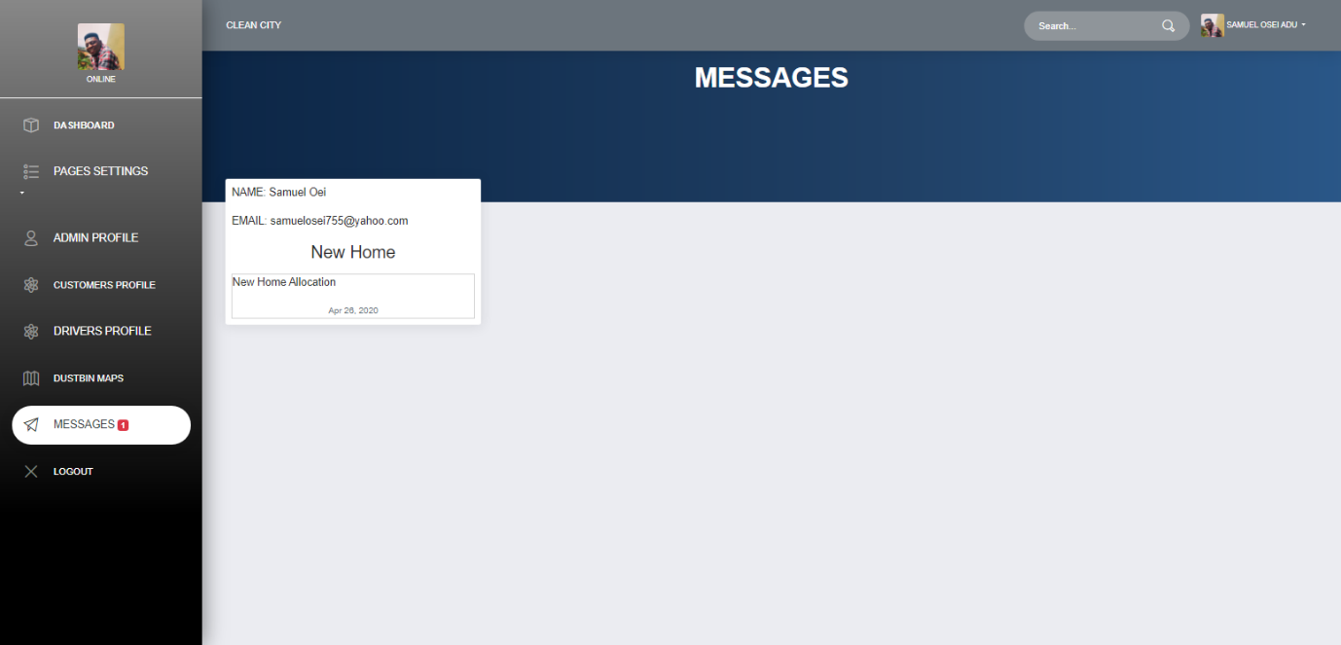

Figure ‑ Messages page.

The above page displays the messages customers send.

### 4.5.1 – Smart IoT Based Architecture.

#### 4.5.1.1 – Hardware Setup

**Fig. 4.1. Trash Talker circuit**

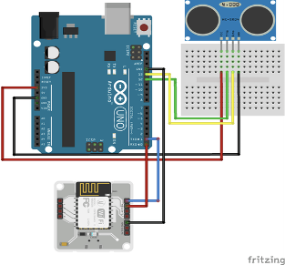

Figure ‑ Trash Talker circuit

The HC-SR04 Ultrasonic Sensor is at the centre of the Trash Talker. The Fritzing breadboard diagram is as shown.

#### 4.5.1.2 – Components Design

Ultrasonic Sensor

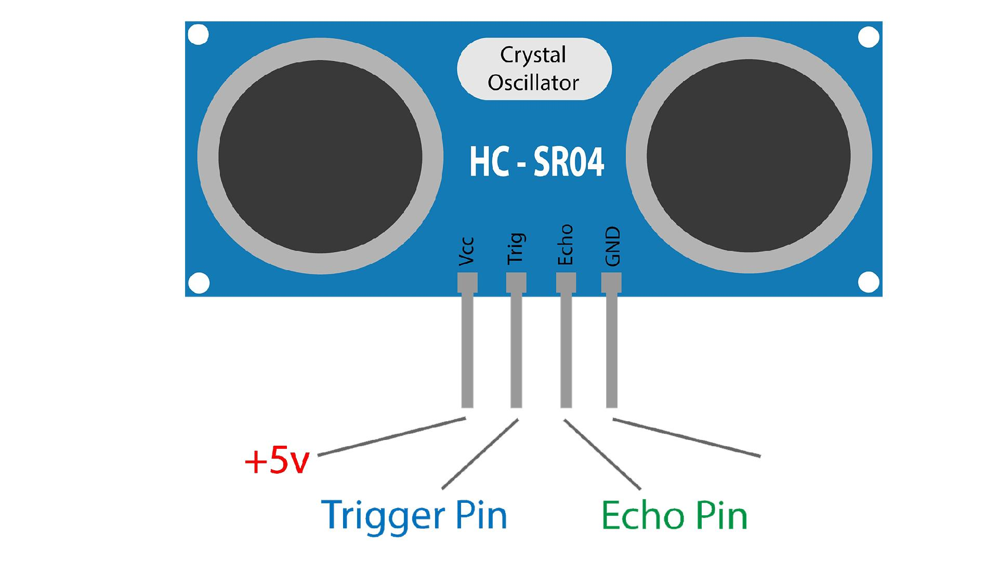

Figure ‑ Ultrasonic Sensor

Arduino Uno Board

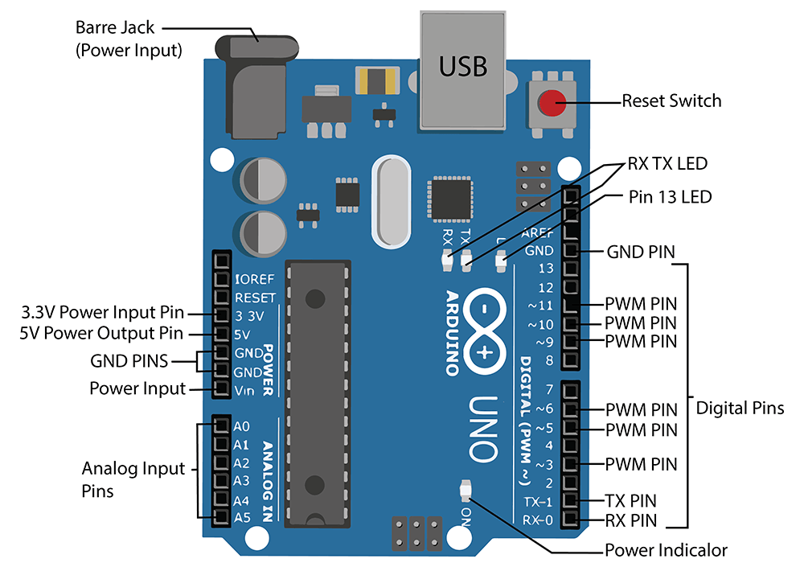

Figure ‑ Arduino Uno Board

### 4.6.1 – Database Design

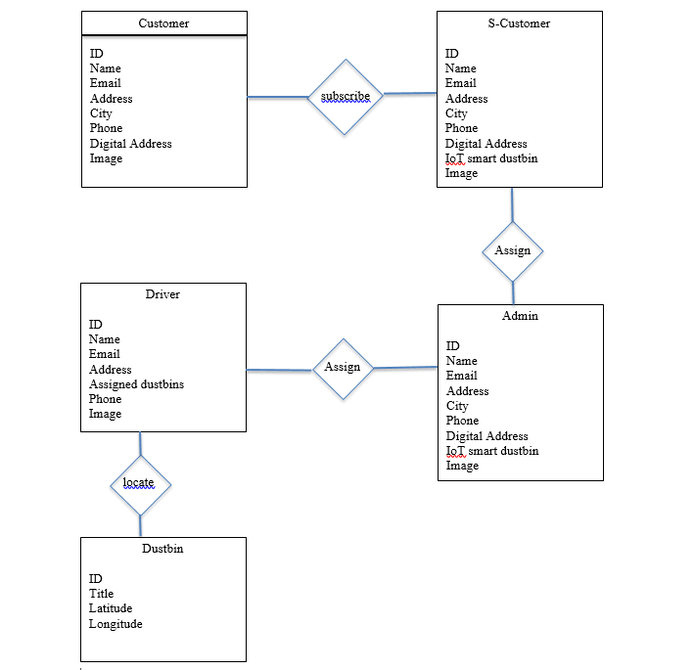

Figure ‑ Database Design

The above diagram is an entity relationship diagram between the various actors involve in the use of the system. The actors (Customer, Driver, Dustbin and the admin).

# CHAPTER 5 - IMPLEMENTATION AND TESTING

## 5.0 - Development Tools And Platforms Consideration

The User Interface is a web application therefore the platform of the device used to access the site does not matter as long as it possesses a browser capable of accessing the internet, to create the web application the main development tools necessary are a text editor. As for the IoT system it does not run dependent on any specific platform.

## 5.1 Mapping Logical Design Onto Physical Platforms

What is required is a practiced and formal approach to gathering data requirements and modelling data. This modelling effort requires a formal approach to the discovery and identification of entities and data elements. Data normalization is a big part of data modelling and database design. A normalized data model reduces data redundancy and inconsistencies by ensuring that the data elements are designed appropriately.

Logical

Before the actual database is implemented it was carefully planned out considering the vital pieces of information required by this smart waste collection system.

Data modeling requires a different mindset than requirements gathering for application development and process-oriented tasks. It is important to think “what” is of interest instead of “how” tasks are accomplished. To transition to this alternate way of thinking, follow these three “rules”:

* Don’t think physical; think conceptual – do not concern yourself with physical storage issues and the constraints of any DBMS you may know. Instead, concern yourself with business issues and terms.
* Don’t think process; think structure – how something is done, although important for application development, is not important for data modeling. The things that processes are being done to are what is important to data modeling.
* Don’t think navigation; think relationship – the way that things are related to one another is important because relationships map the data model blueprint. The way in which relationships are traversed is unimportant to conceptual and logical data modeling.

Data models are typically rendered in a graphical format using an entity-relationship diagram.

Physical

The first step is to create an initial physical data model by transforming the logical data model into a physical implementation based on an understanding of the DBMS to be used for deployment. To successfully create a physical database design you will need to have a good working knowledge of the features of the DBMS including:

* In-depth knowledge of the database objects supported by the DBMS and the physical structures and files required to support those objects.
* Details regarding the manner in which the DBMS supports indexing, referential integrity, constraints, data types, and other features that augment the functionality of database objects.
* Detailed knowledge of new and obsolete features for particular versions or releases of the DBMS to be used.
* Knowledge of the DBMS configuration parameters that are in place.
* Data definition language (DDL) skills to translate the physical design into actual database objects.

Armed with the correct information, you can create an effective and efficient database from a logical data model. The first step in transforming a logical data model into a physical model is to perform a simple translation from logical terms to physical objects. Of course, this simple transformation will not result in a complete and correct physical database design – it is simply the first step. The transformation consists of the following:

* Transforming entities into tables
* Transforming attributes into columns
* Transforming domains into data types and constraints

## 5.4 - Testing

When it comes to testing IoT systems there are two major areas to consider and they each have their own set of tools used to for testing, they are:

1. **Software:**

* [**Wireshark**](https://www.wireshark.org/)**:** This is an Open source application used to monitor the traffic in the interface, source/destination host addresses etc.
* [**Tcpdump**](http://www.tcpdump.org/)**:** This does a similar job that of the Wireshark except, this does not have a GUI. This is a command line based utility which helps the user in displaying the TCP/IP and other packets that are transmitted or received over a network.

1. **Hardware:**

* **JTAG Dongle:** This is similar to a debugger in PC applications. This helps in debugging the target platform code and shows variables step by step.
* [**Digital Storage Oscilloscope**](https://en.wikipedia.org/wiki/Digital_storage_oscilloscope)**:** This is used to check various events with time stamps, glitches in power supply, signal integrity check.
* [**Software Defined Radio**](https://en.wikipedia.org/wiki/Software-defined_radio)**:** This is used to emulate receivers and transmitters for a large range of wireless gateways.

### 5.4.1 - Units/Components Testing

1. Hardware-Software Mesh

IoT is an architecture, which is closely coupled among various hardware and software components. It is not only the software applications that make the system but also the hardware ones, sensors, communication gateways, etc. to play a vital role.

Only functionality testing does not help in completely certifying the system. There is always a dependency on each other in terms of the environment, data transfer, etc. So, it becomes a tedious job as compared to testing a generic system [only software/hardware component].

1. Device Interaction module

As this is an architecture between different set(s) of hardware and software, it becomes mandatory that they talk to each other in real-time/near real-time. When they both integrate with each other, things such as security, backward compatibility, upgrade issues becomes a challenge for the testing team.

1. Real-time data testing

As we have discussed earlier that a Pilot testing/regulatory testing is mandatory for a system such as this, it also becomes very tough to get such data.

Being in a testing team, getting regulatory checkpoints, or getting the system deployed in the pilot is very tough. The step becomes even tougher if the system is related to Healthcare as per our example. So, that stays as a big challenge for the testing team.

1. UI

The IoT is spread across devices belonging to every platform [iOS, Android, Windows, linux]. Now, testing that out on devices can be done but testing it on all possible devices is almost impossible.

We cannot omit the possibility of the UI being accessed from a device that we don’t possess or simulate. That’s a challenge that is tough to overcome.

1. Network availability

Network connection plays a vital role as IoT is all about the data being communicated at faster speeds all the time. IoT architecture has to be tested in all kinds of network connectivity/speeds.

To test this, virtual network simulators are mostly used to vary the network load, connectivity, stability, etc. But, real-time data/network is always a new scenario and the testing team doesn’t know where the bottleneck would develop in the long run

### 5.4.2 - Integration And System Testing

1. Hardware-Software Mesh

IoT is an architecture, which is closely coupled among various hardware and software components. It is not only the software applications that make the system but also the hardware ones, sensors, communication gateways, etc. to play a vital role.

Only functionality testing does not help in completely certifying the system. There is always a dependency on each other in terms of the environment, data transfer, etc. So, it becomes a tedious job as compared to testing a generic system [only software/hardware component].

1. Device Interaction module

As this is an architecture between different set(s) of hardware and software, it becomes mandatory that they talk to each other in real-time/near real-time. When they both integrate with each other, things such as security, backward compatibility, upgrade issues becomes a challenge for the testing team.

1. Real-time data testing

As we have discussed earlier that a Pilot testing/regulatory testing is mandatory for a system such as this, it also becomes very tough to get such data.

Being in a testing team, getting regulatory checkpoints, or getting the system deployed in the pilot is very tough. The step becomes even tougher if the system is related to Healthcare as per our example. So, that stays as a big challenge for the testing team.

1. UI

The IoT is spread across devices belonging to every platform [iOS, Android, Windows, linux]. Now, testing that out on devices can be done but testing it on all possible devices is almost impossible.

We cannot omit the possibility of the UI being accessed from a device that we don’t possess or simulate. That’s a challenge that is tough to overcome.

1. Network availability

Network connection plays a vital role as IoT is all about the data being communicated at faster speeds all the time. IoT architecture has to be tested in all kinds of network connectivity/speeds.

To test this, virtual network simulators are mostly used to vary the network load, connectivity, stability, etc. But, real-time data/network is always a new scenario and the testing team doesn’t know where the bottleneck would develop in the long run.

### 5.4.3 - Deployment Model And Platforms

The process of planning how the IoT solution will be deployed involves ensuring that either your internal or external partner has the capabilities to install, support, and service on-premise during the crucial weeks and months of initial implementation.

Here’s where forward stocking for backup hardware, technical customer support, and tech support for Wi-Fi or cellular networks, gateways, web interfaces, apps, and your new cloud platform all come into play. What if it breaks during the process of installation? What if a critical piece is stolen days before deployment?

Security and data privacy plans laid out in the consulting phase and created during development also come full circle in deploy. If someone’s hacked a protocol, it’s not as simple as the way an IT patch is distributed (software update, and voila it’s fixed!). Each functionality needs to be enabled and tested for interoperability when things change. How does that new software communicate to the cloud platform? Then how would they communicate to devices?

### 5.4.4 - Acceptance Testing

The is system is to function based on these scenarios.

1. Read the waste level in waste bins and if it is below a threshold does not send a notification.
2. Read the waste level in a waste bin and if it is at or beyond a threshold send a notification.

Table illustrating how the system functions using the GIVEN-WHEN-THEN approach

|  |  |  |
| --- | --- | --- |
| GIVEN | WHEN | THEN |
| Waste is in the bin | It is not a threshold level | Do not send message |
| Waste is in the bin | It is at/beyond threshold | Send message |

# 

# CHAPTER 6 - CONCLUSIONS AND RECOMMENDATIONS

## 6.0 - Discussions

In an ideal community, this technology will be well appreciated, but this is not the case for our country. We are still a developing country therefore some of our citizens might be a little sceptical about the idea of using technology to schedule how waste is collected from major areas in the community.

Although this solution is not perfect, there are still quite a number of things that can be done to improve this system for maximum results.

## 6.1 - Achievements

With this project we were able to achieve a few things in our implementation of a solution reading of waste levels in a container, sending messages to a waste collection agent to be delivered to a waste management facility.

## 6.2 - Conclusions

## 6.4 - Recommendations

The system is not perfect and may not be able to withstand certain conditions such as moisture. Therefore providing the system with a casing that allows it to survive adverse weather conditions will improve its performance and longevity.

Also the web application the waste collectors use to receive notifications of the status of waste containers and to navigate to them can be adopted into a mobile application which will make it much more convenient.

## 6.5 - References

1. Adu-Boahen, K., Atampugre, G., Antwi, K.B., Osman, A., Osei, K.N., Mensah, E.A. and Adu-Boahen, A.O. (2014), “Waste management practices in Ghana: challenges and prospect, Jukwa Central Region”, International Journal of Development and Sustainability, Vol. 3 No. 3, pp. 530-546.
2. Kyere, R., Addaney, M. and Ayaribilla Akudugu, J., 2019. *Decentralization And Solid Waste Management In Urbanizing Ghana: Moving Beyond The Status Quo*. [ebook] Available at: <https://www.intechopen.com/books/municipal-solid-waste-management/decentralization-and-solid-waste-management-in-urbanizing-ghana-moving-beyond-the-status-quo> [Accessed 10 June 2020].
3. Ben Ahmed, M., Boudhir, A. and Younes, A., 2019. *Innovations In Smart Cities Applications Edition 2*. Cham: Springer.
4. Anitha, A. (2017). Garbage monitoring system using IoT. IOP Conference Series: Materials Science and Engineering. 263. 042027. 10.1088/1757-899X/263/4/042027.
5. 4 Waste Removals. 2020. *There Are 5 Types Of Waste, Do You Know Them All? - 4 Waste Removals*. [online] Available at: <https://4waste.com.au/rubbish-removal/5-types-waste-know/> [Accessed 11 June 2020].
6. Web.mit.edu. n.d. *Decision Makers’ Guide To Municipal Solid Waste Incineration*. [online] Available at: <https://web.mit.edu/urbanupgrading/urbanenvironment/resources/references/pdfs/DecisionMakers.pdf> [Accessed 11 June 2020].
7. Smullins, C., 2011. *An Introduction To Database Design: From Logical To Physical*. [online] Data and Technology Today. Available at: <https://datatechnologytoday.wordpress.com/2011/11/19/an-introduction-to-database-design-from-logical-to-physical/> [Accessed 11 June 2020].
8. Gupta, A. and Do, D., 2020. *Internet Of Things (Iot) Testing: Challenges, Tools And Testing Approach*. [online] Softwaretestinghelp.com. Available at: <https://www.softwaretestinghelp.com/internet-of-things-iot-testing/> [Accessed 11 June 2020].